MATH 8 UNIT 3

More Graphs, Identities and Trig Equations

NAME: ______________________________________

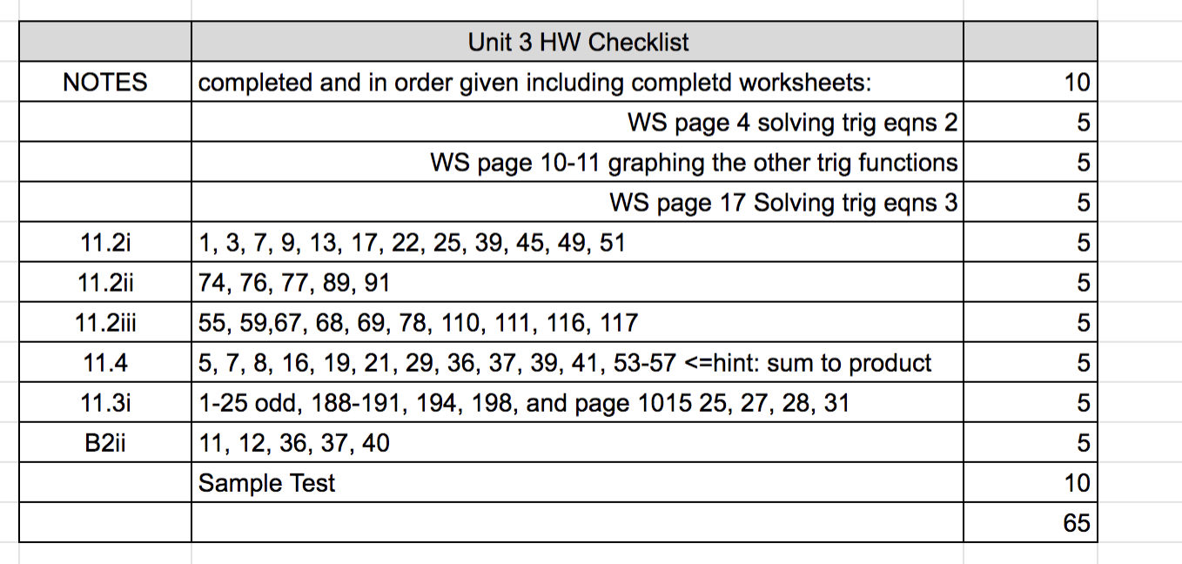

Unit 3– Graphs of the Other Trig Functions, Identities, Inverse Trig and Equations.

More Solving Trigonometric Equations (covered in 11.4 of text, I break into pieces and cover differently)

Multistep Equations: First isolate the trig function first, then solve for the argument

1) Solve: 

2) Solve 

Solving when there is an expression in the argument. First solve for the argument, then the variable.

3) Solve: 

4) Solve tan(  )

5) Solve  *******

Visual explanation

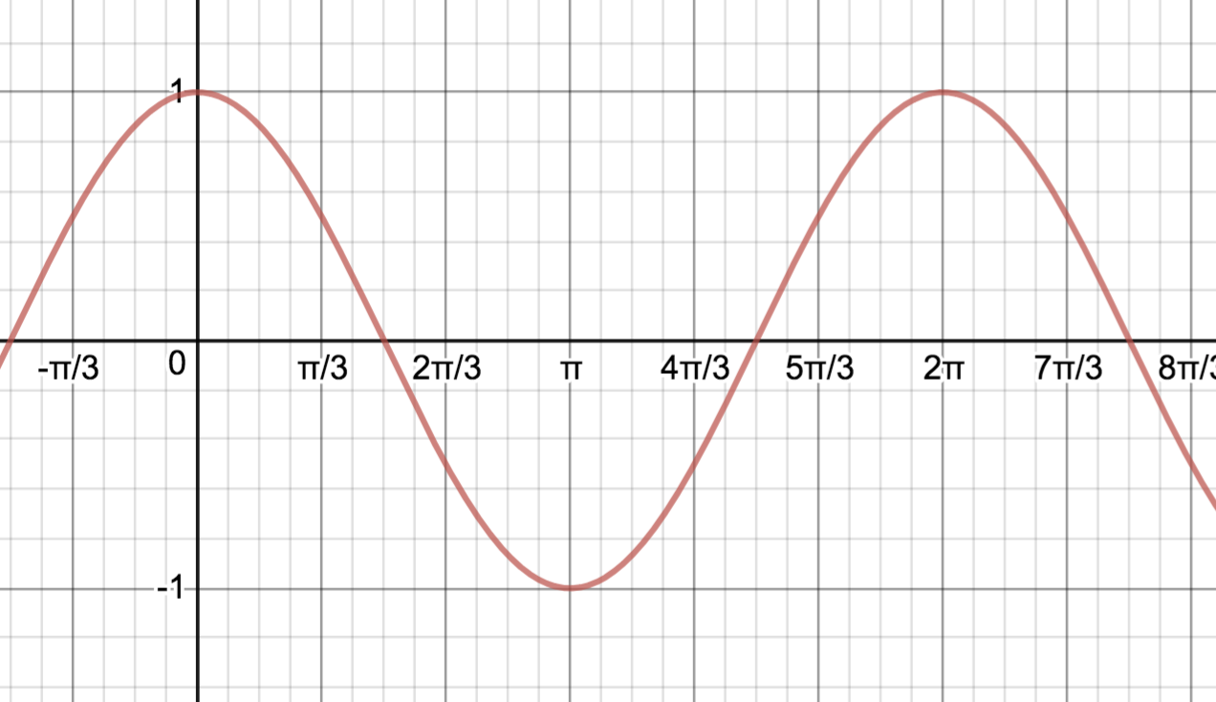

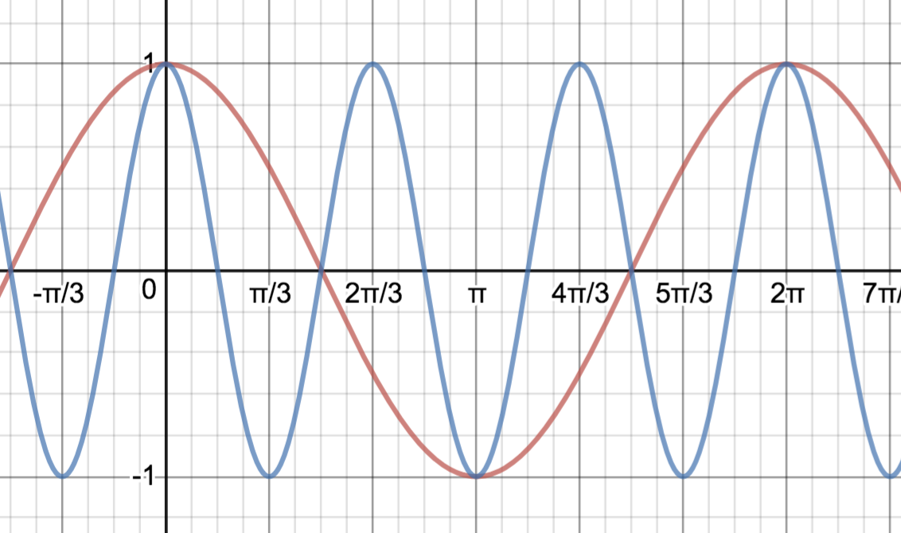

Worksheet – Solving Trigonometric Equations – part ii

(1) Solve the following equations exactly. (all solutions)

(a)  (b)  (c) 

Answers: *  *

(2) Solve the following equations exactly for .

(a)  (b)  (c) 

Answers: *  *

(3) Solve the following equations exactly for .

(a)  (b)  (c) 

have to think on this one

Answers: *no solution  *

Unit 3– Graphs of the Other Trig Functions, Identities, Inverse Trig and Equations.

10.5 Graphs of Tangent, Cotangent, Cosecant and Secant.

For the graphs of secant and cosecant, we can use our knowledge of graphing cosine and sine, together with the reciprocal relationships:

Ex: 

Since , everywhere that __________________,  is ____________, thus where the graph of has an __________________________ the graph of

 has a ____________________.

Also, as gets small  _____________

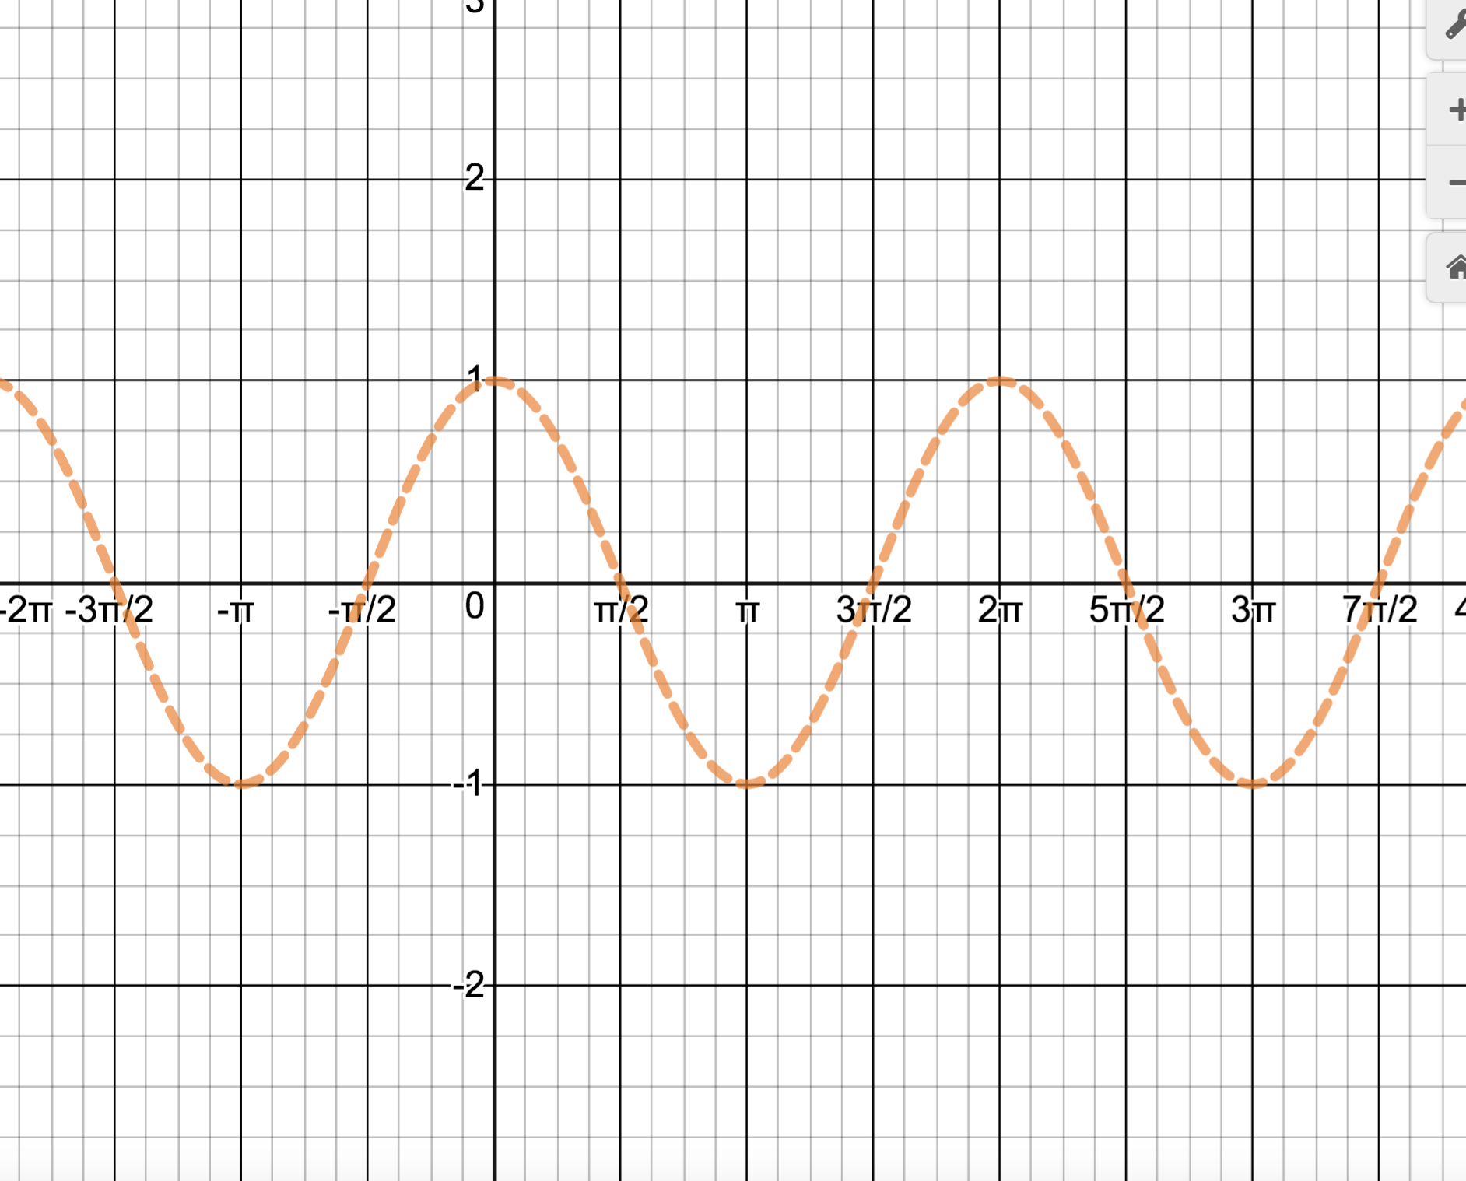

Previously, by the unit circle definition, we determined the domain of  to be

_____________________________ which we can now see on the graph. In addition, the graph tells

us that the range of  is ________________________________

What is the period of ? ________________________________

The graph of  can be found similarly (see text).

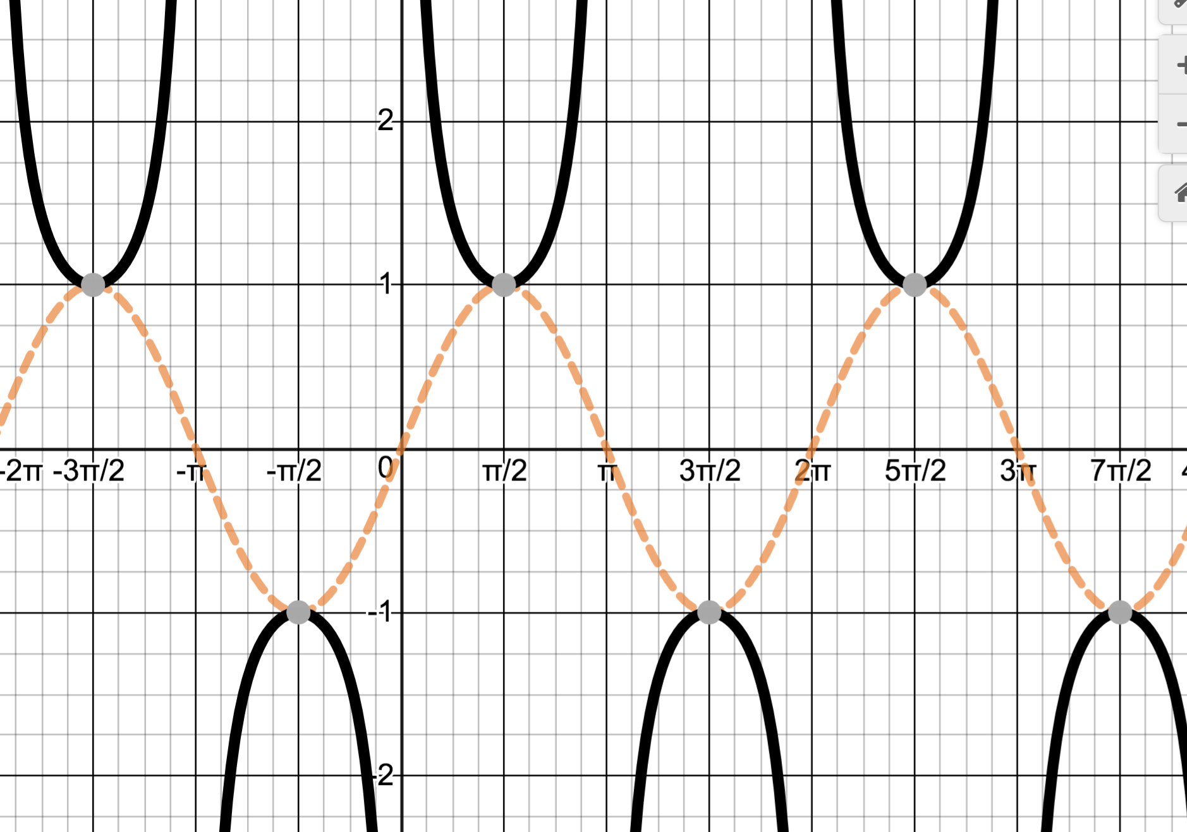

Notice the location of the vertical asymptotes. How would we find them algebraically?

Note domain, range, period

How would you graph  l?

Note: Even though we could use the above graph together with a

transformation (____________________________), it is actually easier to

___________________________________________________

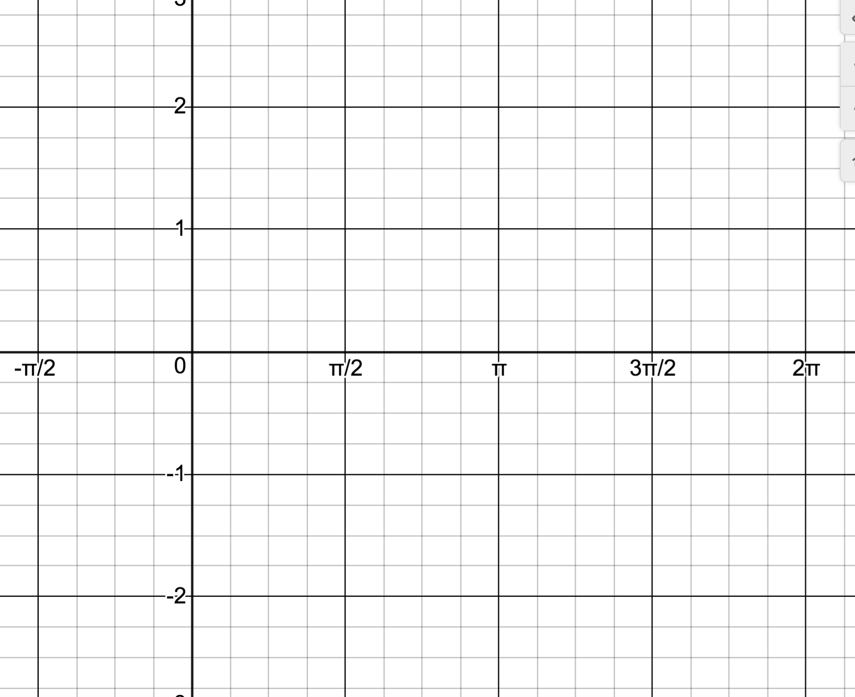

EX: Sketch the graph of .

Note: Even though we could use the above graph together with a

transformation (____________________________), it is actually easier to

___________________________________________________



How would we find the domain and asymptotes algebraically if we didn’t have the graph?

The graph of 

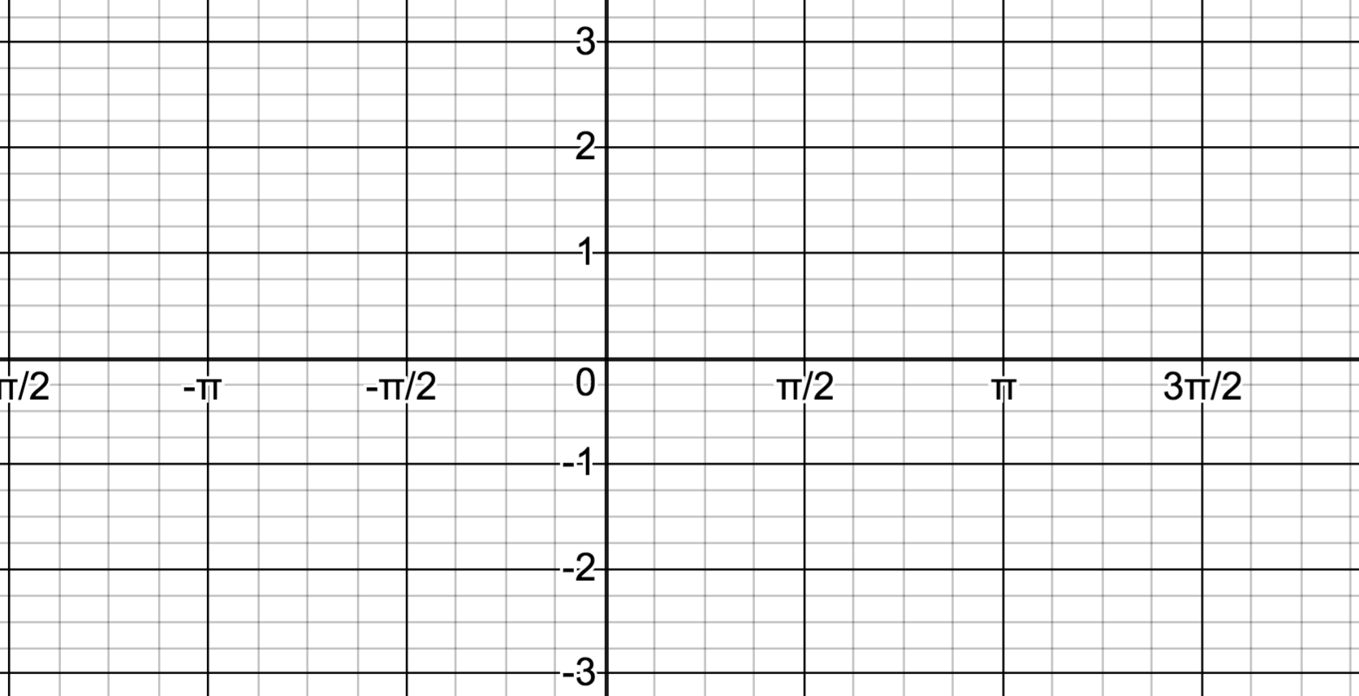

Discuss domain, range, period, odd, asymptotes…

EX: Sketch the graph of 

.

Note: Even though we could use the above graph together with a

transformation (____________________________), it is actually easier to

___________________________________________________



What is the period? ______________________________

In general has period____________________ Find asymptotes by considering where the denominator, . Midway between asymptotes is an x intercept, midway between the x intercept and an asymptote, f(x)=A or -A

EX: Sketch the graph of 

.

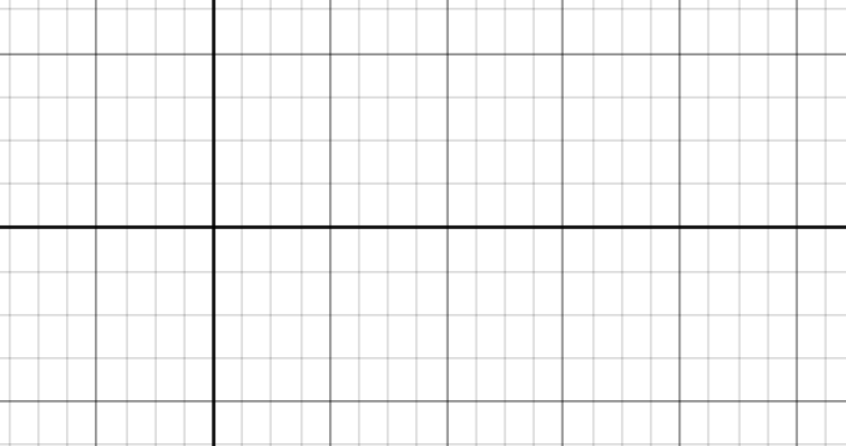

Graph of 

 

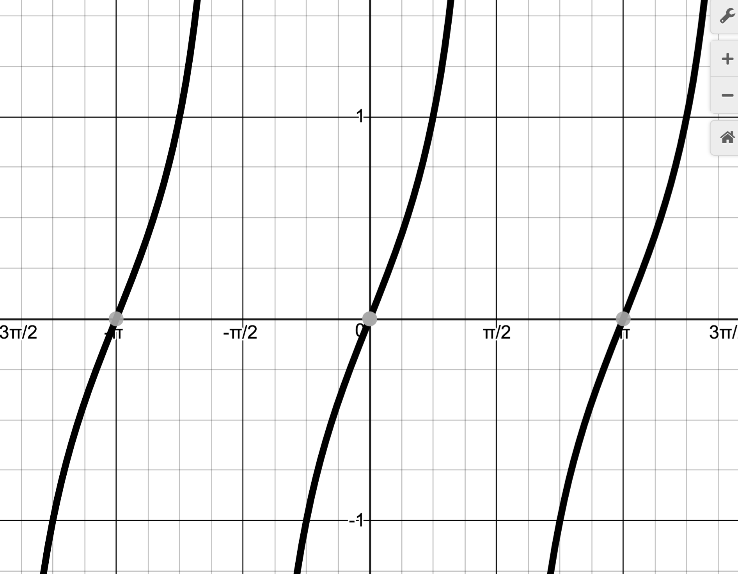 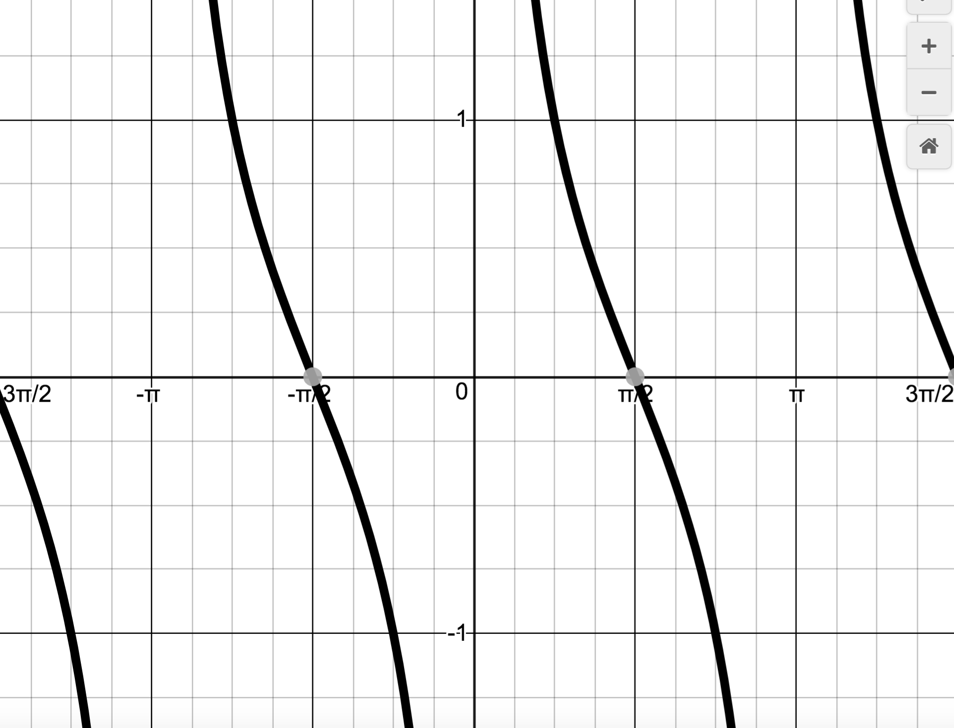

Discuss domain, range, period, odd, asymptotes…

Note: the asymptotes for tangent and cotangent are not in the same location (why?). In addition notice that the tangent graph increases between each pair of asymptotes where the cotangent decreases.

See text for more examples

WS: Graphing the other trigonometric functions.

Graph the following. Label asymptotes. Show scale. Check a point.

(1) 



(2) 



(worksheet cont’d)

(worksheet cont’d)

(3) 



(4) 



Book does in a little more detail. Practice problems from 10.5 as needed to be able to do problems similar to those on this worksheet. 1, 2, 4-11. No need to turn in.

11.2i More Identities

Sum and Difference Formulas:

Recall Function Notation: ____________________________

Development of the identity for 

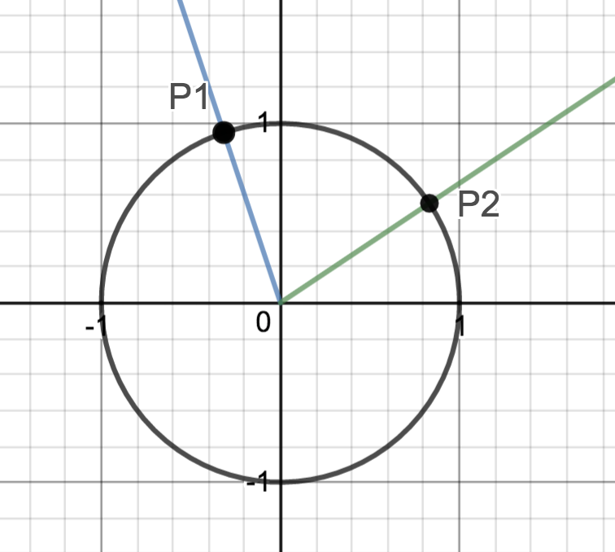 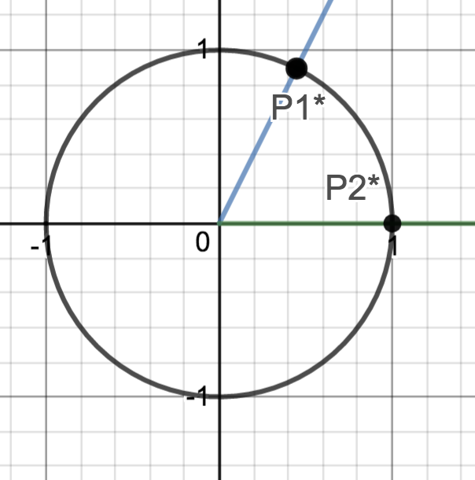

Check on example above

We have shown: 

which we can use to show:



Now, making use of the co-function formulas we saw from section B2, (the cosine of an angle equals the sine of its complement),

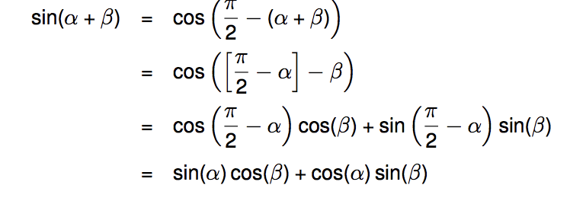

From here we can derive



This leads to:



And similarly for 

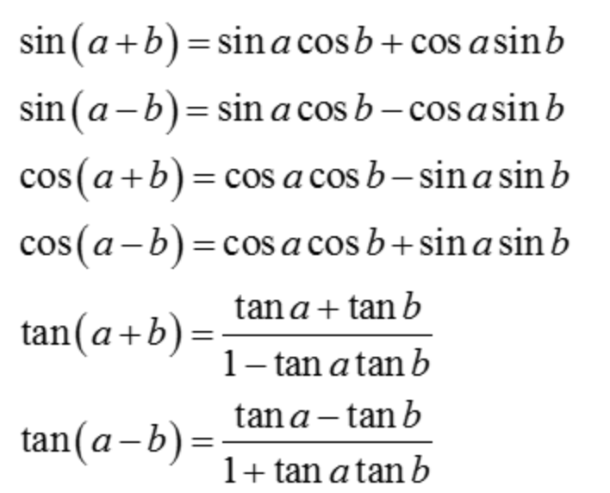

Using the sum and difference formulas:

Ex: Find the exact value of  and 

Ex: Simplify 

Ex: Given that , with a in Quadrant I, and  with b in Quadrant III, find .

Ex: Use the fact that  to derive a formula for 

11.2ii Even More Identities

Double Angle Formulas

Recall Function Notation: ____________________________

Using the fact that , we can show:

Often we use these as a templates.

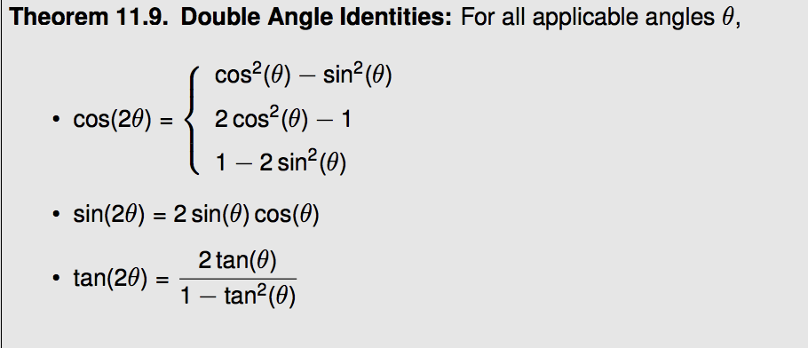

Using the double angle formulas:

EX: Given that P(-1,2) lies on the terminal side of q, find .

EX: Find an identity for in terms of q

EX: Verify the identity 

More Solving Trigonometric Equations (covered in 11.4 of text, I break into pieces)

Use factoring with zero product law.

(1) Solve:  can use substitution

(2) Solve for  Note: _______________________

Using Identities to solve equations.

(3) 

(4) 

(5) Solve for 

*Note: There are many worksheets for practice on the Math 8 page.*

WS: Solving Trig Equations part iii

(1) Solve the following equations:

a)  *Ans: *

b)  *Ans: *

(2) Solve the following equations for :

a)  *Ans: *

b)  *Ans: *

c) *Ans: *

d)  *Ans: *

(3) Solve for :  *Ans: *

11.2iii More Identities

Power Reducing and Half Angle Formulas

From the Double Angle Formulas for cosine, we can derive other useful identities.

 

Power Reducing Formulas

Half Angle Formulas

Using the power reducing and half angle formulas:

EX: Write in terms of terms having power of at most 1. (This is a process that will be very useful in calculus)



EX: Find the exact value of  and .

Note: When using the half angle formulas you must choose _______________________________

and that choice is based on the quadrant of _________________________

EX: If , find  and 

Product to Sum Formulas *(memorization not required)*

Derivation:

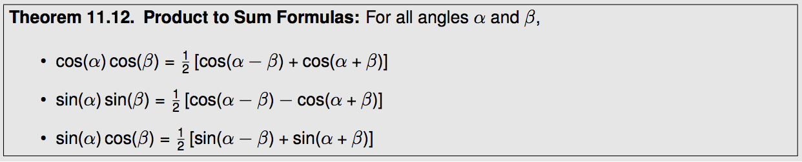

EX: Write as a sum: 

Sum to Product Formulas (also called factoring formulas) *(memorization not required)*

With a substitution of  and , we derive :

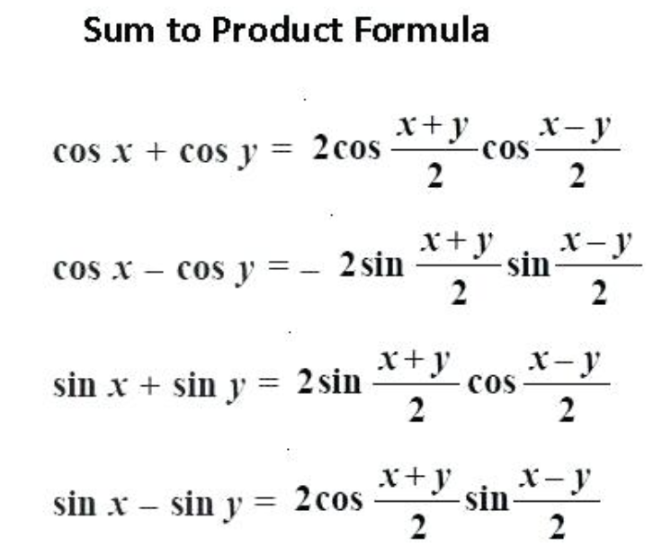

EX: Solve for 

.

11.3i Inverse Trigonometric Functions

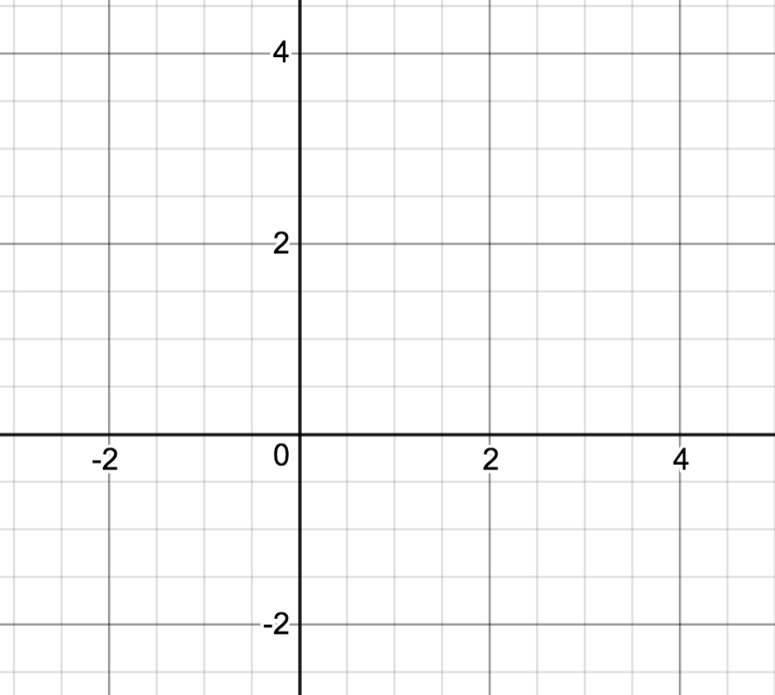

Recall Inverse Functions (section 5.6)

Given ,

1) Find 

2) Graph  and .

3) Find the domain and range of  and .

4) Find  and 

Why is the restriction  necessary?___________________________

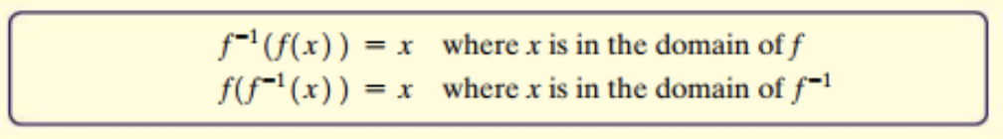

Inverse Sine Function

Does  have an inverse? _________________________________________

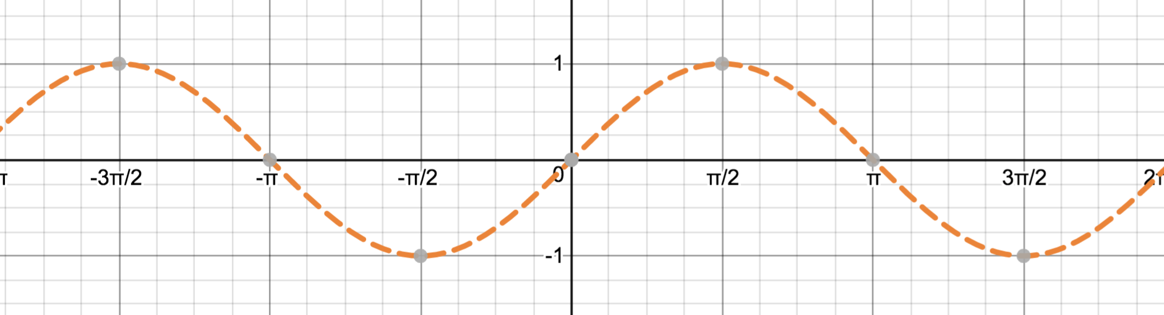

What restriction would we need to make so that at least a piece of this function has an inverse?

Given  ___________________

1) Find 

2) Graph  and .

3) Find the domain and range of  and .

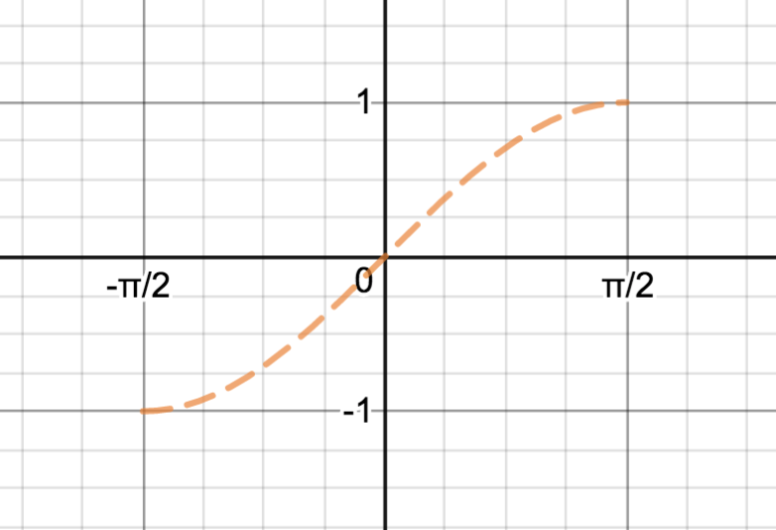

We define  or  to mean 

Note: Both the input and output of this function are real numbers, but it is sometimes helpful to think in terms of angles.

that is let  or  mean 

For example:

 

 

Finding exact values of the inverse sine function for special inputs: (like:______________________)

Ex: 

Set  and re-write according to the definition as ___________________

*In words:  is the real number (or angle) in  whose sine (or y value on the unit circle) is *

Ex: 

Since  is a *function*, ________________________________

Ex:

Ex: ______________________

Ex:  ______________________

Compositions

= _____________ =__________________

=_____________ =__________________

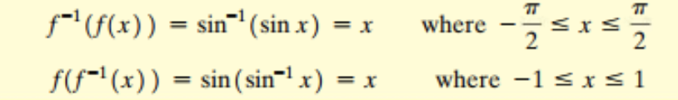

Think about it: =__________________

Using the inverse sine function

Right triangle applications:

1) Find q in the given triangle.

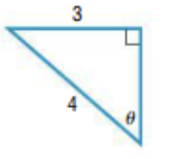

2)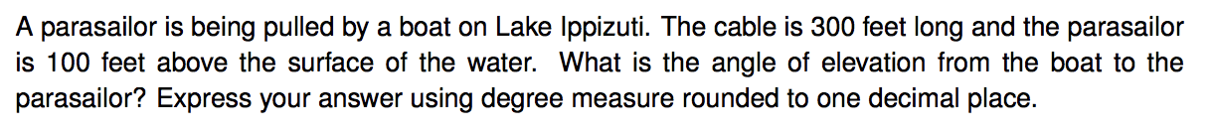

Solving Equations:

We did this same process previously, for where inputs where key number/angle.

Examples: While you are learning the process, I highly encourage you to draw the unit circle and find the location of the terminal sides corresponding to the solution.

Review: Solve:  for 

This is asking us to find the real number (arc length or corresponding angle, in radians) whose corresponding point on the unit circle has_____________value of ½. This occurs at one of our key number/angle inputs. They are “p/6 type” inputs, that is they have a __________________ of p/6 .

Solutions: ________________________

Now Solve:  for 

This is asking us to find the real number (arc length or corresponding angle, in radians) whose corresponding point on the unit circle has_____________value of 1/3. This is not one of our known inputs.

What would the reference angle be? ________________

Solutions: ________________________

Review: Solve:  for 

What would the reference angle be? ________________

Solutions: ________________________

Now Solve:  for 

This is asking us to find the real number (arc length or corresponding angle, in radians) whose corresponding point on the unit circle has_____________value of -3/4. This is not one of our known inputs.

What would the reference angle be? ________________

Solutions: ________________________

Inverse Cosine Function

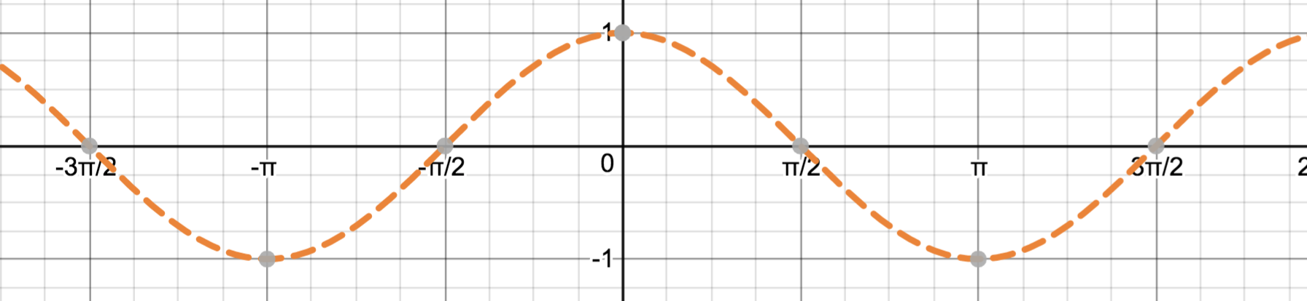

What restriction would we need to make so that at least a piece of this function has an inverse?

Given  ___________________

1) Find 

2) Graph  and .

3) Find the domain and range of  and .

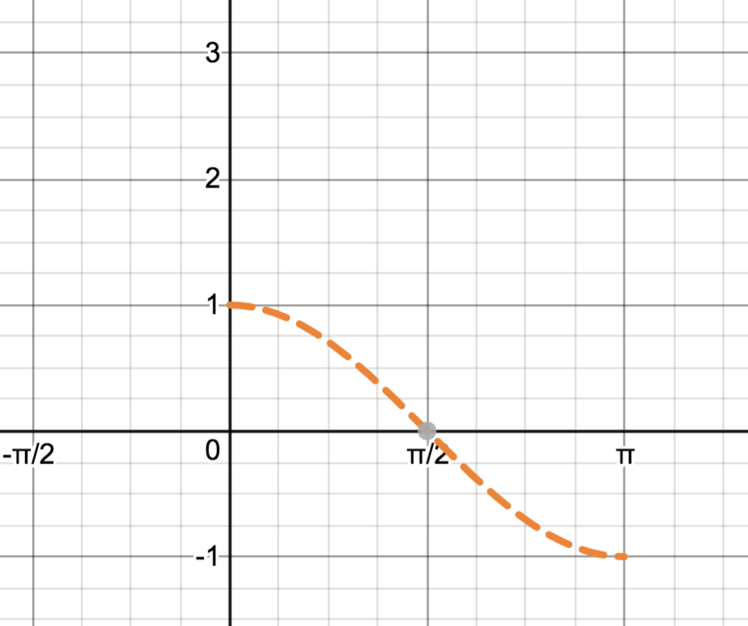

We define  or  to mean 

Note: Both the input and output of this function are real numbers, but it is sometimes helpful to think in terms of angles.

that is let  or  mean 

As before, it is helpful to think of the input/outputs as follows:

 

Finding exact values of the inverse sine function for special inputs:

Ex: 

*In words:  is the real number (or angle) in  whose cosine (or x value on the unit circle) is *

Ex: 

Ex:

Ex:  ______________________

Compositions

= _____________ =__________________

=_____________ =__________________

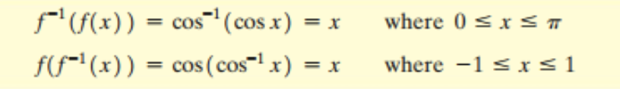

Think about it: =__________________

Solving equations using inverse cosine:

Review: Solve:  for 

What would the reference angle be? ________________

Solutions: ________________________

Now Solve:  for 

This is asking us to find the real number (arc length or corresponding angle, in radians) whose corresponding point on the unit circle has_____________value of 1/3. This is not one of our known inputs.

What would the reference angle be? ________________

Solutions? ___________________________

Review: Solve:  for 

What would the reference angle be? ________________

Solutions: ________________________

Now Solve:  for 

This is asking us to find the real number (arc length or corresponding angle, in radians) whose corresponding point on the unit circle has_____________value of -1/4. This is not one of our known inputs.

What would the reference angle be? ________________

Solutions: ________________________

Inverse Tangent Function

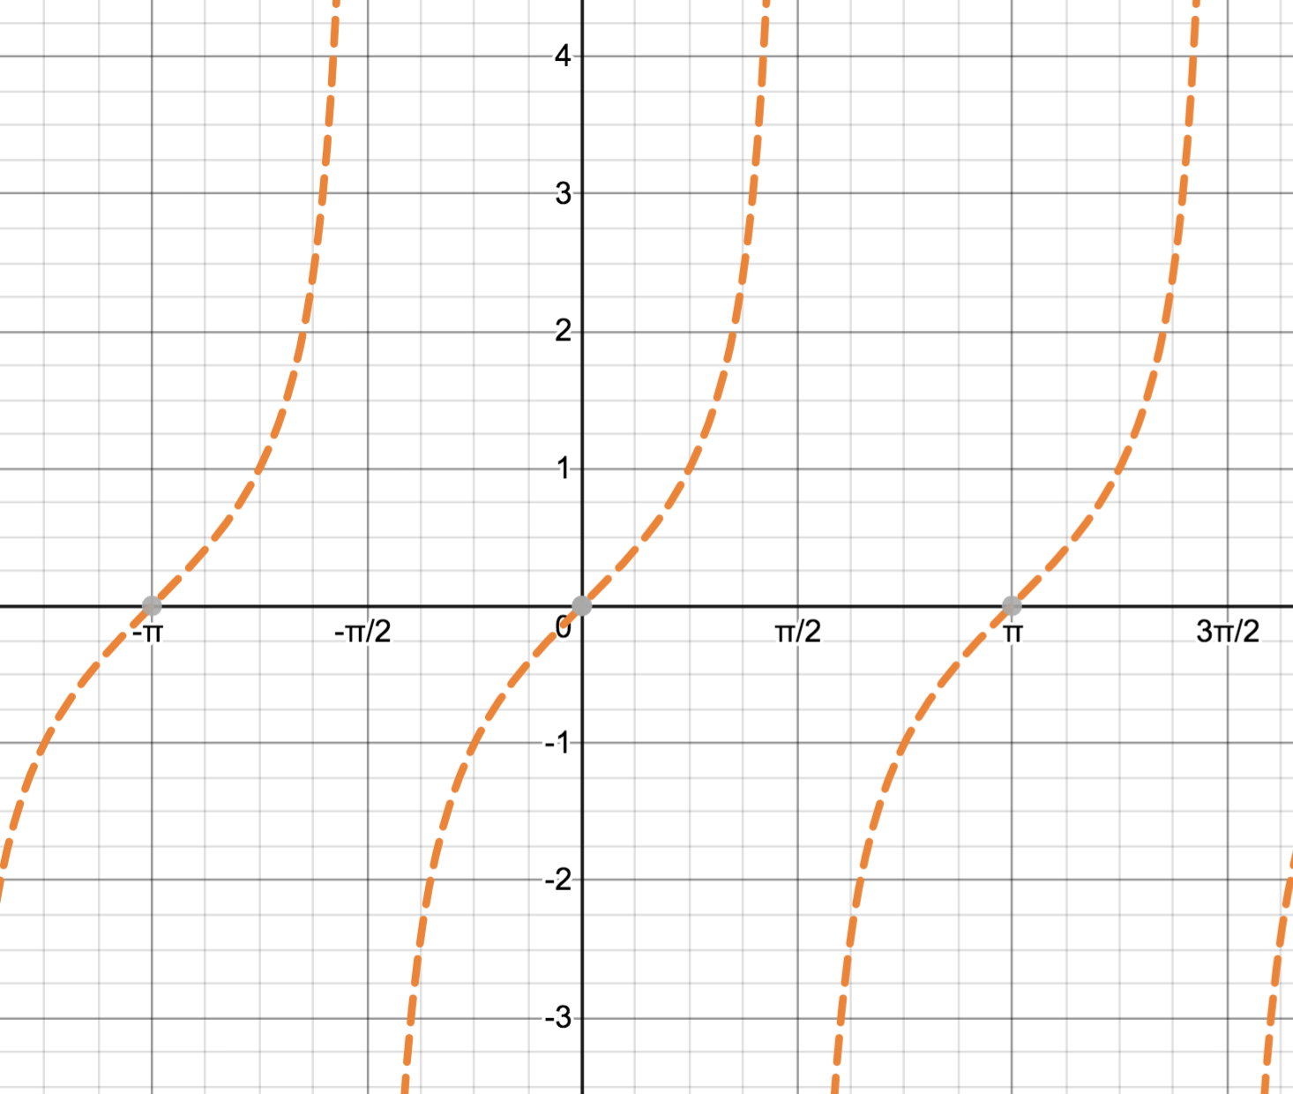

What restriction would we need to make so that at least a piece of this function has an inverse?

Given  ___________________

1) Find 

2) Graph  and .

3) Find the domain and range of  and .

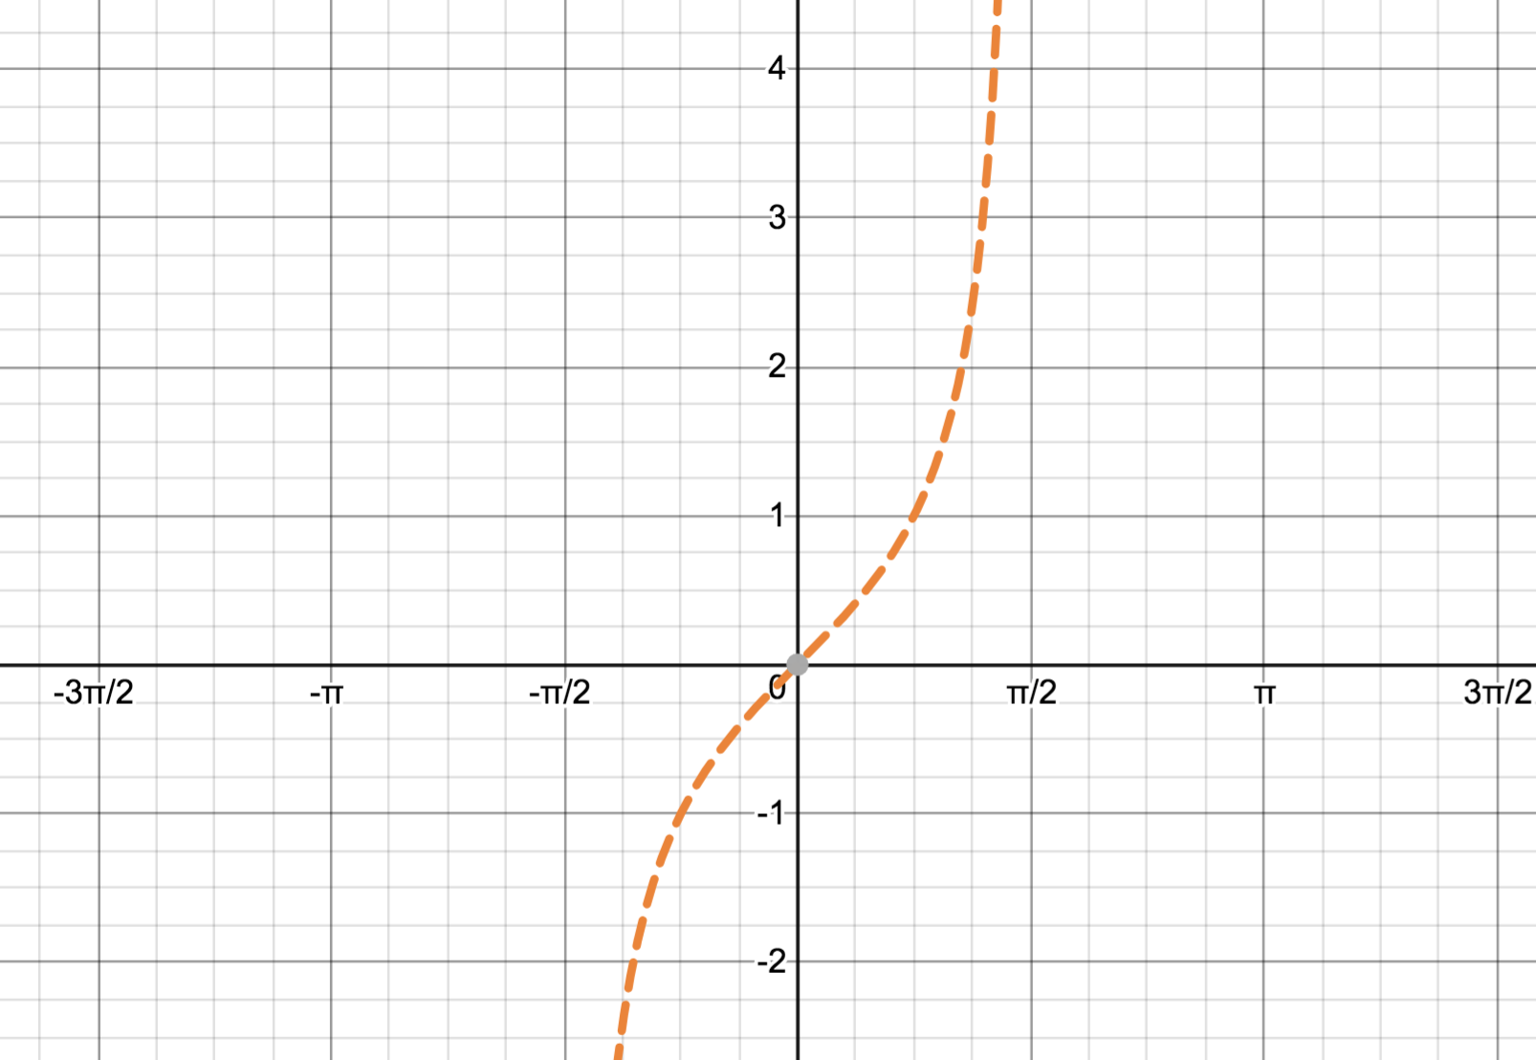

We define  or  to mean 

As before, both the input and output of this function are real numbers, but it is sometimes helpful to think in terms of angles.

 

Finding exact values of the inverse sine function for special inputs:

Ex: 

*In words:*  *is the real number (or angle) in  whose tangent* 

Ex: 

Ex:

Ex:  ______________________

Compositions

Similar to the case for cosine and sine,

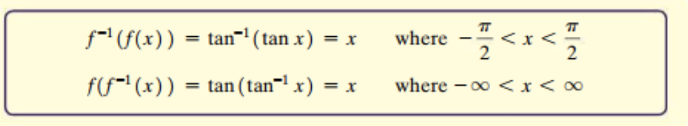

Solving equations using inverse tangent:

Solve:  for 

What would the reference angle be? ________________

Solutions? ___________________________

Solve:  for 

What would the reference angle be? ________________

Solutions? ___________________________

What if we were asked for ALL solutions? _____________________________-

11.3ii Inverse Trigonometric Functions – The other inverse functions and mixed compositions

The other inverses:



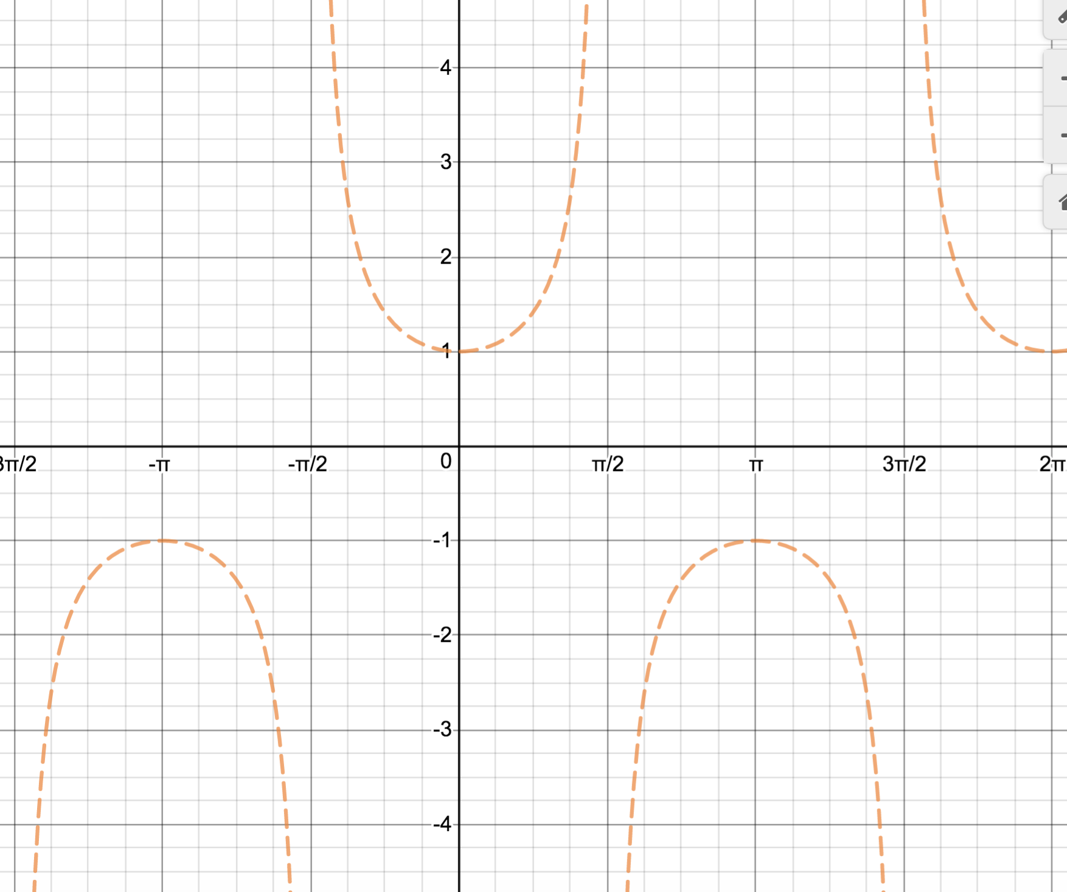 

“Trig friendly” restrictions: _____________ “Calculus friendly” restrictions:_______________

 

 

See the book for  and . You do not need to memorize these restrictions, but know how to find values for a given set of restrictions.

Mixed Compositions – common in calculus

Find exact values:

 

 